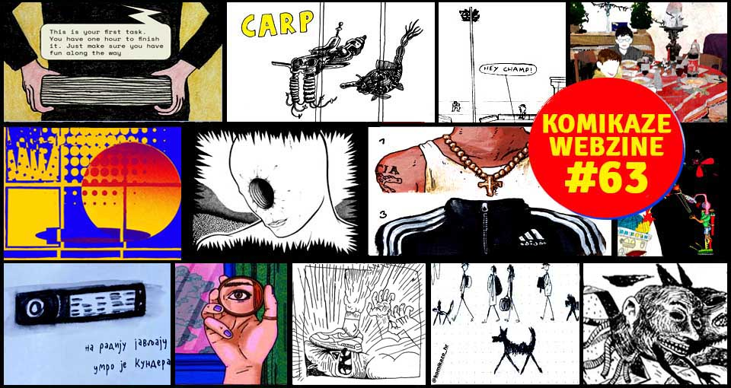
komikaze webzine #63 je vani! / is out! – hvala svima na sudjelovanju! / thanks to all for the participation!
click click: vuk palibrk < / > dobre_brlje < / > neo one < / > sugarhotline < / > patrick jannin < / > stipan tadić < / > ivana armanini < / > desko < / > entonaze < / > madalina mitroi < / > luka čačić < / > pietro giovanni macciotta < / > tribef tribe
novi webzine komikaze br. 63 na 89 stranica predstavlja 13 autora_ica suvremenog, art i alternativnog stripa; 8 premijerno u “komikaze mreži”. autori_ce dolaze iz hrvatske, srbije, albanije, rumunjske, italije & francuske. novo web izdanje je većinom rezultat xxkomikaze 2023. turneje: brtonigla – bari – napulj – sarajevo – sućuraj – split – benkovac, na kojoj smo otkrili mnoštvo novih autora_ica. dio webzina će biti tiskan u komikaze (dvojezičnom) albumu krajem godine.
new webzine no. 63 on the 89 pages present 13 authors of the contemporary, art and alternative comics; 8 for the first time in the “komikaze network”. authors come from croatia, serbia, albania, romania, italy & france. new web edition is the mostly result of the xxkomikaze 2023 tour: brtonigla – bari – napulj – sarajevo – sućuraj – split – benkovac. where we discovered plenty of new authors. part of the webzine will be printed in the komikaze (bilingual) album at the end of the year.
program komikaze 2023. je podržan od ministarstva kulture i medija republike hrvatske i grada zagreba. / komikaze programme 2023 is supported by the ministry of culture and media of the republic croatia and city zagreb.

o autorima / about authors:

13 autora_ica / iz: Hrvatske, Srbije, Italije, Albanije, Rumunjske, Francuske / 89 str / 8 premijerno! - 13 authors / from: Croatia, Serbia, Italy, Albania, Romania, France / 89 pg / 8 for the first time!
- CLICK CLICK: Vuk Palibrk
(1987., Pančevo, Srbija) Živi u Beogradu. Crta ilustracije i animirane filmove ali najviše voli crtati stripove. / (1987, Pancevo, Serbia) Lives in Belgrade. He draws illustrations and animated films but most of all he likes drawing comics. - IG: https://instagram.com/vpalibrk/
———
- CLICK CLICK: Dobre brlje aka Marija Kosić
(1988., Smederevo, Srbija) Živi i radi u Beogradu. Završila je Medicinski fakultet, Univerzitet u Beogradu. Fokus: ilustracija / (1988, Smederevo, Serbia) Living and working in Belgrade. Graduated from Medical faculty, University of Belgrade. Focus: illustration - IG: https://www.instagram.com/dobre_brlje/
———
- CLICK CLICK: Desko aka Miloš Ćosović
(1989., Beograd, Srbija) Bavi se crtežom, analognim i digitalnim, nerijetko i pokretnim u video formatu sa zvukom u prostoru. Pored ljubavi prema ilustraciji, uživa u stvaranju interaktivnih radova na webu. / (1989, Belgrade, Serbia) Works with drawing, analog and digital, often moving in video format with sound in space. In addition to his love for illustration, he enjoys creating interactive works on the web. - IG: https://www.instagram.com/vitamin_desko/
———
- CLICK CLICK: Madalina Mitroi
(1987., Bukurešt, Rumunjska) Grafička dizajnerica i ilustratorica iz Berlina. Fokus: dizajn, ilustracija, strip, animacija, keramika / (1987, Bucharest, Romania) Graphic designer and Illustrator from Berlin. Focus: design, illustration, comics, animations, ceramics - IG: https://www.instagram.com/madalinamitrol/
———
- CLICK CLICK: Entonaze aka Enton Nazeraj
se radio albanskim roditeljima u Rimu, što ga čini “rođenim migrantom”. Završio je školu za ilustraciju Studio B5 u Trastavere i od tada pokušava ispričati svoju priču kroz kolaže, crteže i slike. / Born in Rome to Albanian parents, which makes him a "Born Immigrant." He completes his studies at the illustration school Officina B5 in Trastevere, and since then, he has been trying to tell his stories through collages, drawings, and paintings. - IG: https://instagram.com/entonaze/
———
- CLICK CLICK: sugar hotline aka Jelena ilić
(1973., Zemun, Srbija) ilustratorica i grafička dizajnerica po formalnom obrazovanju i po svom neformalnom opredjeljenju. Diplomirala je (2003.) i magistrirala (2008.) slikarstvo na FLU u Beogradu. Članica je ULUS-a od 2004. Imala je dvadesetak samostalnih, i učestvovala na više grupnih izložbi. Živi i radi u Zemunu. / (1973, Zemun, Serbia) illustrator and graphic designer by formal education and by her informal commitment. Graduated (2003) and master's degree (2008) in painting at FLU in Belgrade. She has been a member of ULUS since 2004. She had about twenty solo exhibitions and participated in several group exhibitions. She lives and works in Zemun. - IG: https://www.instagram.com/sugarhotline/
———
- CLICK CLICK: Patrick Jannin
(1971., Langes, Francuska) Patrick je prvo studirao psihologiju. Radio je većinu vremena s mentalnim bolesnicima. Kasnije, nakon prve samostalne izložbe slika, završio je studij za grafički dizajn i art školu u Le Havre. Tamo je napravio prvi strip. Završio je 2000.-te i 23 godine je u polju između crteža. fotografije i slikanja. / (1971, Langes, France) Patrick first studied psychology. He worked several years with people suffering of mental illness, then, after his first personal exhibition of paintings, he studied graphic design at the art school of Le Havre. There he made his first comics. Since he graduated in 2000, he has been 23 years in the field of drawing, sculpture, photography and painting. - WEB: https://www.patrickjannin.com/ + IG: http://instagram.com/pjannin/
———
- CLICK CLICK: Stipan Tadić
(1986., Zagreb, Hrvatska) Živi na relaciji Zagreb - New York, SAD. Fokus: strip, ilustracija, slikarstvo. Završio je Akademiju likovnih umjetnosti u Zagrebu i Magisterij na likovnoj akademiji, Columbia, NY / (1986, Zagreb, Croatia) Lives between Zagreb and New York, USA. Focus: comic, illustration, painting. Graduated at Academy of Fine Arts in Zagreb and Master studies in fine art, Columbia university, NY - WEB: http://stipantadic32.blogspot.com/ + IG: https://www.instagram.com/stipan.tadic/
———
- CLICK CLICK: Luka Čačić
(1989., Zaprešić, Hrvatska) Završio je Akademiju likovnih umjetnosti u Zagrebu, Hrvatska. Fokus: strip, slikarstvo, keramika / (1989, Zapresic, Croatia) Graduated at Academy of Fine Arts in Zagreb, Croatia. Focus: comics, painting, ceramics - Behance: https://www.behance.net/lukacacic + IG: https://www.instagram.com/luka_van_cacic
———
- CLICK CLICK: Pietro Giovanni Macciotta
(1999., Torino, Italija) Strip umjetnik i illustrator. Živi u Bologni, Italija. / (1999, Turin, Italy) Comic artist and illustrator. Lives in Bologna, Italy. - IG: https://www.instagram.com/pie_dino/
———
- CLICK CLICK: tribef tribe
Strip je napravila anonimna grupa autora okupljena oko organizacije tribef tribe (pleme f20) u Srbiji. / The comic was made by an anonymous group of authors gathered around the organization tribef tribe (tribe f20) in Serbia. - link
———
- CLICK CLICK: NeO-ONE aka Tiziano Battista
Lo-fi glazbenik, pisac i vizualni umjetnik iz Italije. Opsjednut je čudnim art pokretima undergrounda. Stil mu je inspiriran grafikama iz 90-ih, mangama mračne fantazije i punk letcima iz 80-ih. Živio je u Milanu (Italija), Ottawi (Kanada) i Londonu (Engleska), radeći dosadne poslove danju i stvarajući umjetnost noću. Stripove objavljuje od 2017. / Lo-fi musician, writer and visual artist from Italy. Passionate about weird underground art movements. His art style is inspired by 90's graphics, dark fantasy manga and punk flyers of the '80s. He has lived in Milan (Italy), Ottawa (Canada) and London (England) doing odd jobs during the day and creating art in the night. He has published comics since 2017. - IG: https://www.instagram.com/neooneart/
———
- CLICK CLICK: Ivana Armanini
Strip umjetnica i mikroizdavačica iz Zagreba, Hrvatska. Vodi Komikaze od 2002. Završila: Škola za Primijenjenu umjetnost i dizajn; Akademija likovnih umjetnosti u Zagrebu, Hr. Fokus: strip, DIY, izdavaštvo / Comic artist and micro-publisher from Zagreb, Croatia. Leads Komikaze since 2002. Graduated: School of Applied Arts & Design; Academy of fine Arts in Zagreb, Croatia. Focus: comics, DIY, publishing - WEB: http://ivanaarmanini.net/ / IG: https://www.instagram.com/ivana_armanini/

